**DreamBankCard Application setup**

1. Download project from Git repository.
2. Once downloaded, build respective service using “gradleew build” command.

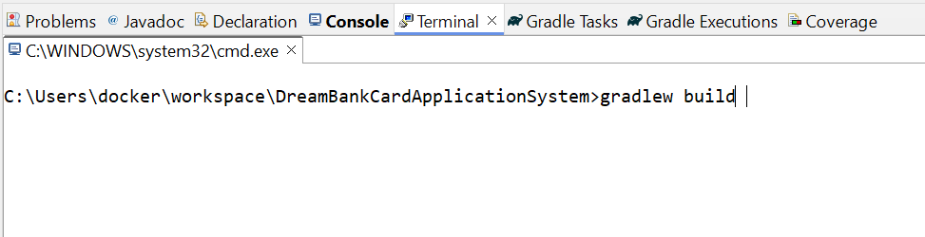

1. Once all services build has been completed, go to docker and build images fro each service as shown below. You can use below commands to build images.
   1. docker build -t dreambankcardapplication:1.0 . (Build DreamBankCardApplication image)
   2. docker build -t equifaxservice:1.0 . (Build Equifax Serviceimage)
   3. docker build -t transunionservice:1.0 . (Build Transunion Serviceimage)
   4. docker build -t experianservice:1.0 . (Build Experian Serviceimage)

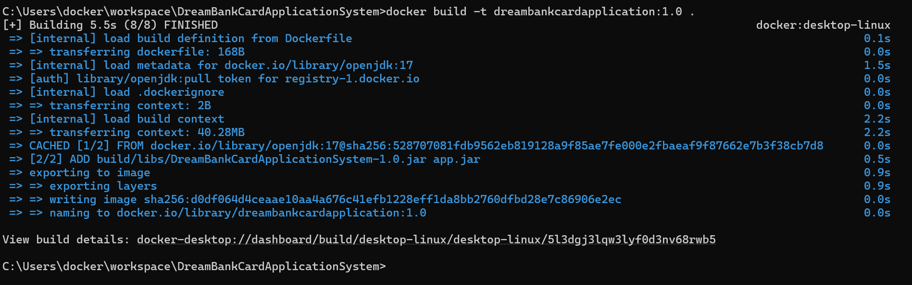

1. Once all application images done, use following commands to create images for MongoDB and Prometheus images.
   1. docker pull mongo:latest ( Pull latest MongoDB images)
   2. docker pull prom/Prometheus:latest (Pull latest Prometheus image)
2. Once all images has been created please use below command to check all images.
   1. Docker images

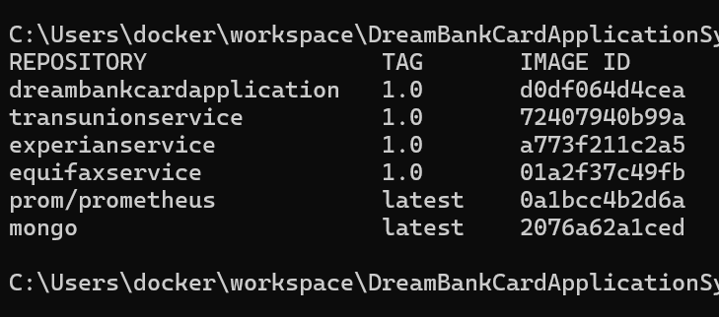

1. Execute “docker-compose up” command as shown below.

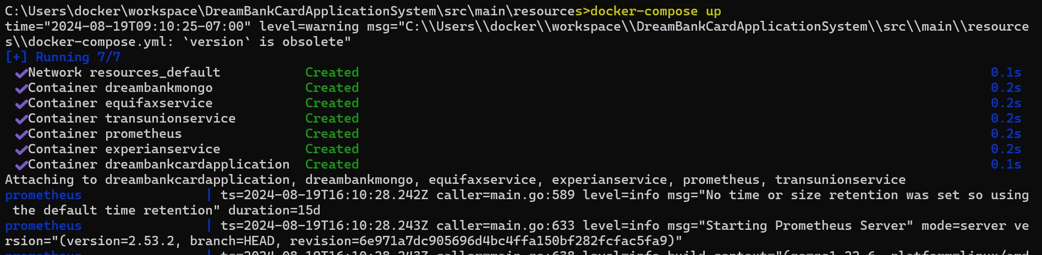

1. Execute swagger URL : <http://localhost:8080/swagger-ui/index.html> from bowser and perform operations. (You will see all curl command and Http Error code details once you will expand each request)

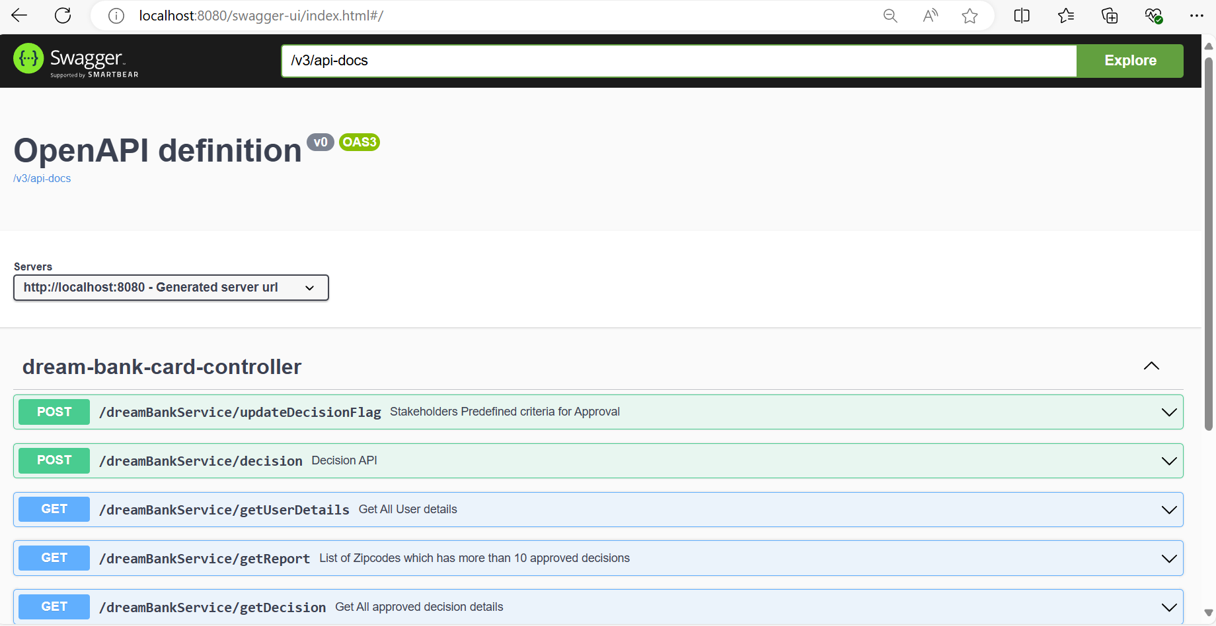

1. Check Prometheus URL : <http://localhost:9090/targets?search=>

You can monitor all services from this portal as shown below.

